 | 14.1.1 Editors - Video Sequence Editor - Header - Tools and Options
Table of content
Detailed table of content 1
Header tools and options - Preview view 3
Timeline 3
Pivot Point 3
Display Mode 3
Display Channels 4
Show Gizmo 4
Show Overlay 4
Options 5
Show Metadata 5
Zoom to Fit 5
Header tools and options - Sequencer View 5
Timeline 5
Overlap Mode 5
Snap 5
Show Overlay 6
Options 7
Preview as Backdrop 7
Show Seconds 7
Sync visible range 7
Cache 7
Show Markers 8
Lock Markers 8
Sync Markers 8
Limit View to Content 8
Header tools and options - Sequencer & Preview view 8

Detailed table of content
Detailed table of content
Detailed table of content 1
Header tools and options - Preview view 4
Timeline 4
Pivot Point 4
Display Mode 4
Image Preview 4
Luma Waveform 4
Chroma Vectorscope 4
Histogram 4
Display Channels 5
Color and Alpha 5
Color 5
Show Gizmo 5
Viewport Gizmos 5
Show Overlay 5
Preview Overlays 5
Image Outline 5
2D Cursor 5
Frame Overlay 5
Safe Areas 5
Metadata 5
Annotations 5
Options 6
Show Metadata 6
Zoom to Fit 6
Header tools and options - Sequencer View 6
Timeline 6
Overlap Mode 6
Expand 6
Overwrite 6
Shuffle 6
Snap 6
Snapping Settings 6
Snap to 6
Current Frame 6
Hold Offset 7
Ignore 7
Muted Strips 7
Sound Strips 7
Snap Current Farmes to Strips 7
Show Overlay 7
Sequencer Overlays 7
Name 7
Source 7
Duration 7
Color Tags 7
Offset 7
F-Curves 7
Retiming 7
Thumbnails 8
Grid 8
Waveforms 8
Waveform Style 8
Options 8
Preview as Backdrop 8
Preview during translation 8
Show Seconds 8
Sync visible range 8
Cache 8
Show Cache 8
Final Images 9
Raw Images 9
Pre Process Images 9
Composite Images 9
Show Markers 9
Lock Markers 9
Sync Markers 9
Limit View to Content 9
Header tools and options - Sequencer & Preview view 9

Header tools and options - Preview view

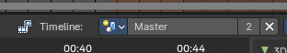
Timeline
The timeline drop down “pins” a selected scene to the Sequencer. This overrides the scene selection of the Sequencer timeline.

Note: This is useful with the Bforartists 3D Sequencer addon to synchronize the Sequencer Scene Strips with the 3D View.

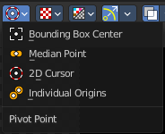
Pivot Point
The Pivot Point is the center of your object or your selection. The names should be self explaining.

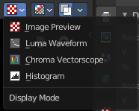
Display Mode
How to display the preview video.

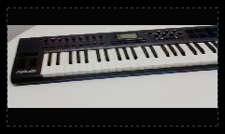
Image Preview
Displays the image material.

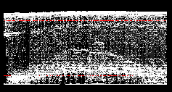
Luma Waveform
Displays the luma waveform of the image.

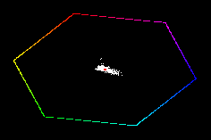
Chroma Vectorscope
Displays the chroma vectorscope of the image.

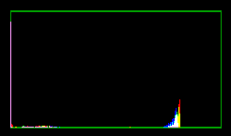
Histogram
Displays a histogram of the image.

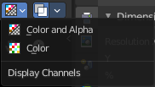

Display Channels
What channels of the video to display.

Color and Alpha
Display the color channels and alpha channel.

Color
Display just the color channels.

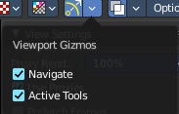
Show Gizmo
Show or hide the viewport gizmos.

Viewport Gizmos
What kind of gizmos to show.

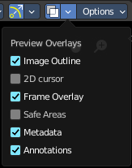
Show Overlay
Turn on or off all overlays.

Preview Overlays

Image Outline
Outline the selected image element.

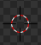
2D Cursor
Show the 2d cursor.

Frame Overlay
Show the frame overlays.

Safe Areas
Show the safe area overlays.

Metadata
Show the Metadata overlay.

Annotations
Show the annotations.

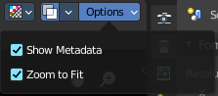
Options

Show Metadata
Show metadata of first visible strip in the viewport.

Zoom to Fit
Automatically zoom preview image to fully fit into the preview window. Note that zooming in or out turns off the feature then.

Header tools and options - Sequencer View

Timeline
The timeline drop down “pins” a selected scene to the Sequencer. This overrides the scene selection of the Sequencer timeline.

Note: This is useful with the Bforartists 3D Sequencer addon to synchronize the Sequencer Scene Strips with the 3D View.

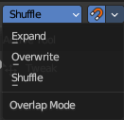
Overlap Mode
How to resolve overlap after transformation.

Expand
Move strips until there is no overlap anymore.

Overwrite
Trim or split strips to resolve overlap.

Shuffle
Move transformed strip to nearest free space to resolve overlap.

Snap
Snap to strip edges or current frame.

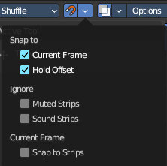
Snapping Settings

Snap to

Current Frame
Snap to the current frame

Hold Offset
Snap to strip Hold offsets.

Ignore

Muted Strips
Ignores muted strips.

Sound Strips
Ignores sound strips.

Snap Current Farmes to Strips
Sets the current frame to the start or end point of the selected clip.

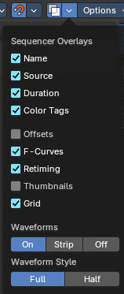
Show Overlay
Turn on or off all overlays.

Sequencer Overlays

Name
Show the name of the clip.

Source
Show the source of the clip.

Duration
Display the duration of the clip.

Color Tags
Display the strip color tags in the sequencer.

Offset
What offset frame to use, relative to the current frame position.

F-Curves
Display the strip opacity/Volume curve.

Retiming
Display the retiming keys on top of the strips.

Thumbnails
Draw thumbnails as strip overlay. This works for movie and image strips. To draw thumbnails, this overlay has to be enabled and strips must be tall enough.

Grid
Show the grid lines.

Waveforms
How waveforms are displayed.

Waveform Style
What waveform style to use.

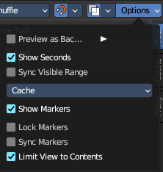
Options

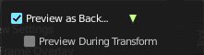
Preview as Backdrop
Display the result as a backdrop under the strips.
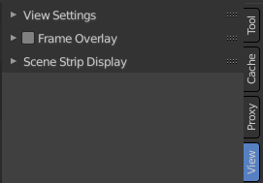
When you turn on Preview as Backdrop, then you will activate the View Settings, Frame Overlay and Scene Strip Display panels from the Preview mode. Please have a look there for the descriptions.

Preview during translation
Show a preview of the transformed frames.

Show Seconds
Show the timing in the timeline area in seconds instead of frames.

Sync visible range
Synchronize the visible timeline range with other visible time based editors.

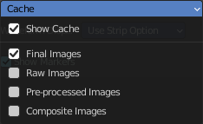
Cache
Cache settings.

Show Cache
Visualize cached images in the timeline.

Final Images
Show the final images.

Raw Images
Show the raw images.

Pre Process Images
Show the pre process images.

Composite Images
Show the composite images.

Show Markers
Display the markers menu and the markers at the bottom in the timeline.

Lock Markers
Prevent marker editing.

Sync Markers
Transform markers with the strips.

Limit View to Content
Limit timeline height to maximum used channel slots.

Header tools and options - Sequencer & Preview view

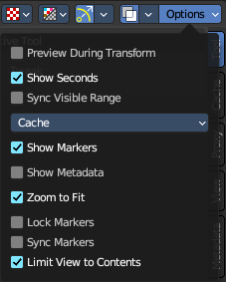
The tools in the Sequencer & Preview view mode are usually the same than in the single modes. Both showing at the same time. With one exception in the options panel. Preview as backdrop is not showing in this mode.

